SIMATS ENGINEERING
ASSESSMENT TOOL 3: Application Based Questions

COURSE NAME: | Cloud Computing and  Big Data Analytics | COURSE CODE: | CSA1514

COURSE OUTCOME COVERED
CO2: Analyze virtualization architectures to identify performance and security issues in cloud computing environments. (BL3)

Dave's Taxonomy: Manipulation (Level 2)  Question Count: 5 | Total Marks: 25

Code of Conduct
I PINDIBOINA SAI DEEPAK (192411047) certify that this submission is my original work and that I have adhered to the guidelines specified for this assessment.
I understand that any violation of academic integrity rules will result in disciplinary action. Signature of the student: Sai Deepak

Assessment Tasks Application Based Questions
- A company experiences unpredictable traffic spikes during seasonal sales. Explain how cloud auto-scaling and load balancing can handle this demand efficiently. How does this approach reduce downtime and improve user experience? What role do monitoring tools play in this setup? Relate your answer to a real-world e-commerce scenario.

- An organization wants to store large volumes of backup data securely in the cloud. Discuss how cloud storage solutions ensure durability and data redundancy.
How can encryption and access control protect sensitive backup data? Explain the cost advantages compared to traditional storage systems. Provide an example of a disaster recovery use case.
- A mobile app company plans to deploy its application globally. Explain how content delivery networks (CDNs) improve performance and reduce latency. How do edge servers enhance user experience across regions? Discuss how cloud providers support global availability. Relate this to a real-time streaming or gaming application.

- A financial institution requires strict compliance and data security in cloud usage. Explain how cloud providers support regulatory compliance and auditing. What role do logging, monitoring, and encryption play in security? How can the company ensure data sovereignty requirements are met? Give an example involving sensitive financial transactions.
- A development team wants to adopt containerization for application deployment. Explain how containers differ from virtual machines in terms of performance and resource usage. How does orchestration (like Kubernetes) simplify deployment and scaling? Discuss portability benefits across different cloud environments.
Provide an example of a microservices-based application.

Application Based Questions Rubric
Criteria | Weightage | Level 4 - Exemplary | Level 3 - Proficient | Level 2 - Developing | Level 1 - Beginning
Relevance to Application | 25% | Response directly  addresses the given use case with strong  relevance | Mostly relevant response | Partially relevant | Weak  relevance
Use of Cloud Concepts | 25% | Applies  appropriate concepts accurately | Mostly accurate  application | Basic application only | Incorrect concept usage
Practical Insight | 20% | Shows strong real-world understanding | Shows  reasonable practical understanding | Limited practical insight | No practical insight
Completeness | 15% | Response covers all required  aspects | Covers most aspects | Covers only basic aspects | Incomplete response
Clarity | 15% | Clear and  concise answer | Generally clear | Some confusion in expression | Poor clarity

Question 1: Auto-Scaling and Load Balancing for Seasonal Traffic
Question: A company experiences unpredictable traffic spikes during seasonal sales. Explain how cloud auto-scaling and load balancing can handle this demand efficiently. How does this approach reduce downtime and improve user experience? What role do monitoring tools play in this setup? Relate your answer to a real-world e-commerce scenario.

Answer
Cloud auto-scaling and load balancing work together to maintain application performance when user demand changes quickly. Auto-scaling automatically adds or removes computing resources, such as virtual machine instances or container replicas, according to workload demand. Scaling policies can use CPU utilization, request count, queue length, or other metrics. During a sudden increase in traffic, new instances are launched; when demand falls, extra capacity can be removed to reduce unnecessary spending.
A load balancer distributes incoming requests across healthy application instances. It can use health checks to avoid sending traffic to failed or overloaded instances. This prevents a single server from becoming a bottleneck and supports high availability. If one instance fails, requests can be routed to other healthy instances, reducing the chance that the whole application becomes unavailable.
This approach improves the user experience by keeping pages responsive, reducing timeouts, and allowing customers to complete searches, add products to carts, and make payments during peak periods. It reduces downtime by responding to increased demand and by routing traffic away from unhealthy resources. However, scaling is not instantaneous, so systems should use suitable minimum capacity, predictive or scheduled scaling for known events, and sensible scaling thresholds.
Monitoring tools are essential because they collect metrics, logs, and alerts. Teams can track CPU and memory usage, request latency, error rates, traffic volume, database connections, and payment-service failures. Alerts help engineers identify unusual patterns and investigate problems. Dashboards and historical data can also be used to tune scaling policies before future sales events.
Example: During a major online shopping festival, an e-commerce website may experience several times its normal traffic. A cloud auto-scaling group launches additional web and application servers as request volume rises. A load balancer distributes customers among these servers and stops routing requests to an unhealthy instance. Monitoring detects increasing latency or payment errors and alerts the operations team. After the sale, the system scales down to normal capacity, helping balance reliability with cost.
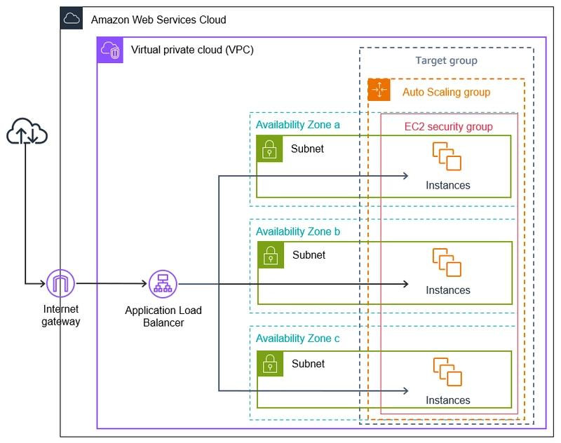

Question 2: Secure and Cost-Effective Cloud Backup Storage
Question: An organization wants to store large volumes of backup data securely in the cloud. Discuss how cloud storage solutions ensure durability and data redundancy. How can encryption and access control protect sensitive backup data? Explain the cost advantages compared to traditional storage systems. Provide an example of a disaster recovery use case.

Answer
Cloud storage services are designed to keep data available and durable by storing copies across multiple devices and, depending on the service and configuration, across separate facilities or geographic regions. Redundancy helps protect against disk failures, hardware faults, and certain site-level incidents. Durability refers to the likelihood that stored data will not be lost over time, while availability refers to whether the data can be accessed when needed. These are related but different properties.
Organizations should choose a storage class and redundancy option based on recovery requirements, access frequency, retention duration, and budget. Backups should be versioned where appropriate, tested regularly, and protected from accidental deletion or ransomware. Immutable retention or object-lock features can help prevent backup copies from being changed or deleted during a defined period. A separate account or administrative boundary for backups can reduce the impact of compromised production credentials.
Encryption protects data confidentiality. Data should be encrypted in transit using secure protocols and at rest using the storage provider’s encryption capabilities or customer-managed keys where required. Access control should follow the principle of least privilege: only authorized users and services should be able to read, write, restore, or delete backup data. Multi-factor authentication, role-based access control, key rotation, private network access, and audit logs add further protection.
Cloud backup can reduce upfront costs because an organization does not need to purchase and maintain all storage hardware, power, cooling, physical space, and replacement equipment itself. Capacity can grow as needed, and lower-cost archival tiers may be suitable for infrequently accessed data. However, retrieval fees, data transfer charges, minimum storage durations, and restore time objectives should be considered when comparing total costs.
Example: A hospital or retail organization may back up databases and files to cloud object storage on a daily schedule. If a local server room becomes unavailable due to fire, flood, hardware failure, or a ransomware incident, the IT team can provision replacement infrastructure and restore clean backup copies in the cloud or another location. Recovery plans should define recovery time objective (RTO) and recovery point objective (RPO), and restoration should be tested before a real disaster occurs.
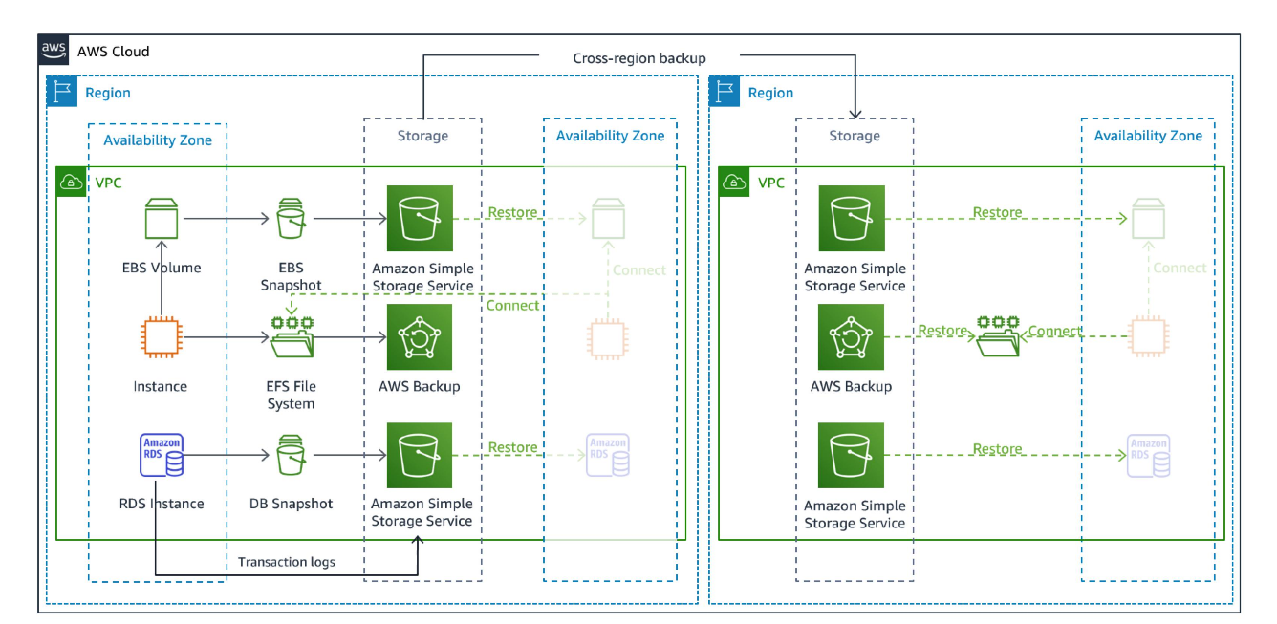

Question 3: CDNs, Edge Servers, and Global Application Performance
Question: A mobile app company plans to deploy its application globally. Explain how content delivery networks (CDNs) improve performance and reduce latency. How do edge servers enhance user experience across regions? Discuss how cloud providers support global availability. Relate this to a real-time streaming or gaming application.

Answer
A content delivery network (CDN) is a distributed network of servers that caches and delivers content from locations closer to end users. Frequently requested static resources, such as images, videos, stylesheets, application files, and software downloads, can be served from a nearby point of presence rather than from a single origin server. This reduces the physical distance data travels, decreases latency, and can reduce load on the origin infrastructure.
Edge servers bring selected processing or content delivery closer to users. They can terminate connections, cache content, apply security rules, and perform certain lightweight functions near the user. Edge delivery is particularly useful when many users in different countries request the same content. Dynamic requests that require a central database may still need to travel to the origin, so application architecture and data placement also affect performance.
Cloud providers support global availability through multiple regions and availability zones, global load balancing, managed CDNs, replicated storage, DNS routing, and regional deployment options. An application can place services in more than one region and direct users to an appropriate healthy endpoint. High availability requires deliberate design: replication, failover policies, consistent configuration, monitoring, and tested recovery procedures. A CDN alone does not guarantee that the full application is globally available.
Example: A live-streaming application can distribute video segments through CDN edge locations so viewers in different countries receive content from nearby servers. This reduces buffering and improves startup time while lowering repeated traffic to the origin. For an online multiplayer game, a provider may place game servers in several regions and direct players to a suitable region to reduce round-trip time. Competitive games may also need careful matchmaking, regional state management, and protection against network attacks.
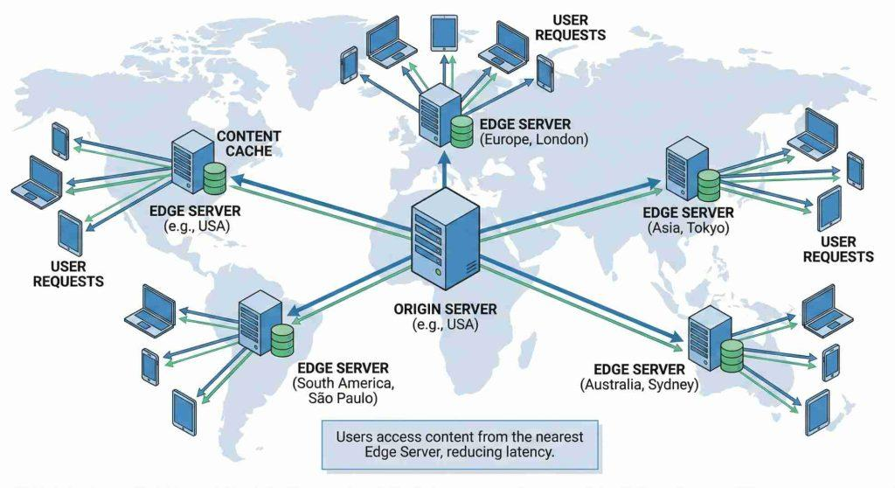

Question 4: Compliance, Auditing, and Data Security in Financial Cloud Systems
Question: A financial institution requires strict compliance and data security in cloud usage. Explain how cloud providers support regulatory compliance and auditing. What role do logging, monitoring, and encryption play in security? How can the company ensure data sovereignty requirements are met? Give an example involving sensitive financial transactions.

Answer
Cloud providers support compliance by offering security controls, certifications, compliance reports, policy tools, identity services, encryption capabilities, audit logging, and documentation that customers can use as part of their own compliance program. The exact standards and obligations depend on the country, type of financial service, data involved, and applicable regulations. Using a compliant cloud service does not automatically make the customer’s entire application compliant; the institution remains responsible for its configuration, access policies, data handling, and operational processes.
Logging creates a record of events such as sign-ins, permission changes, API calls, database access, and administrative actions. Monitoring analyzes logs and metrics to identify unusual activity, service degradation, or policy violations. Alerts and a defined incident-response process help security teams investigate events quickly. Logs should be protected from unauthorized alteration, retained for the required period, and reviewed regularly.
Encryption protects sensitive information while it is transmitted and while it is stored. Strong identity and access management limits who can access transaction data. Multi-factor authentication, least-privilege permissions, network segmentation, secure key management, vulnerability management, backups, and regular security testing provide additional safeguards. Sensitive payment or account data should be exposed only to services and personnel that genuinely require it.
Data sovereignty means that data is subject to the laws and jurisdiction associated with where it is stored or processed. To address sovereignty requirements, the institution should identify applicable legal and regulatory obligations, select appropriate cloud regions, configure storage and processing locations, review provider contracts and subprocessors, and understand where logs, backups, replicas, and support access may occur. Region selection alone may not address every legal requirement, so legal, risk, and compliance teams should validate the design.
Example: When a customer transfers money, the transaction service authenticates the customer, checks authorization, and records the transaction through controlled services. Encryption protects data in transit and at rest, while audit logs record relevant access and administrative activity. Monitoring may flag unusual transaction patterns or repeated failed logins. If regulations require certain customer records to remain within a specific jurisdiction, the institution configures storage and processing accordingly and verifies that backups and logs follow the same requirements.
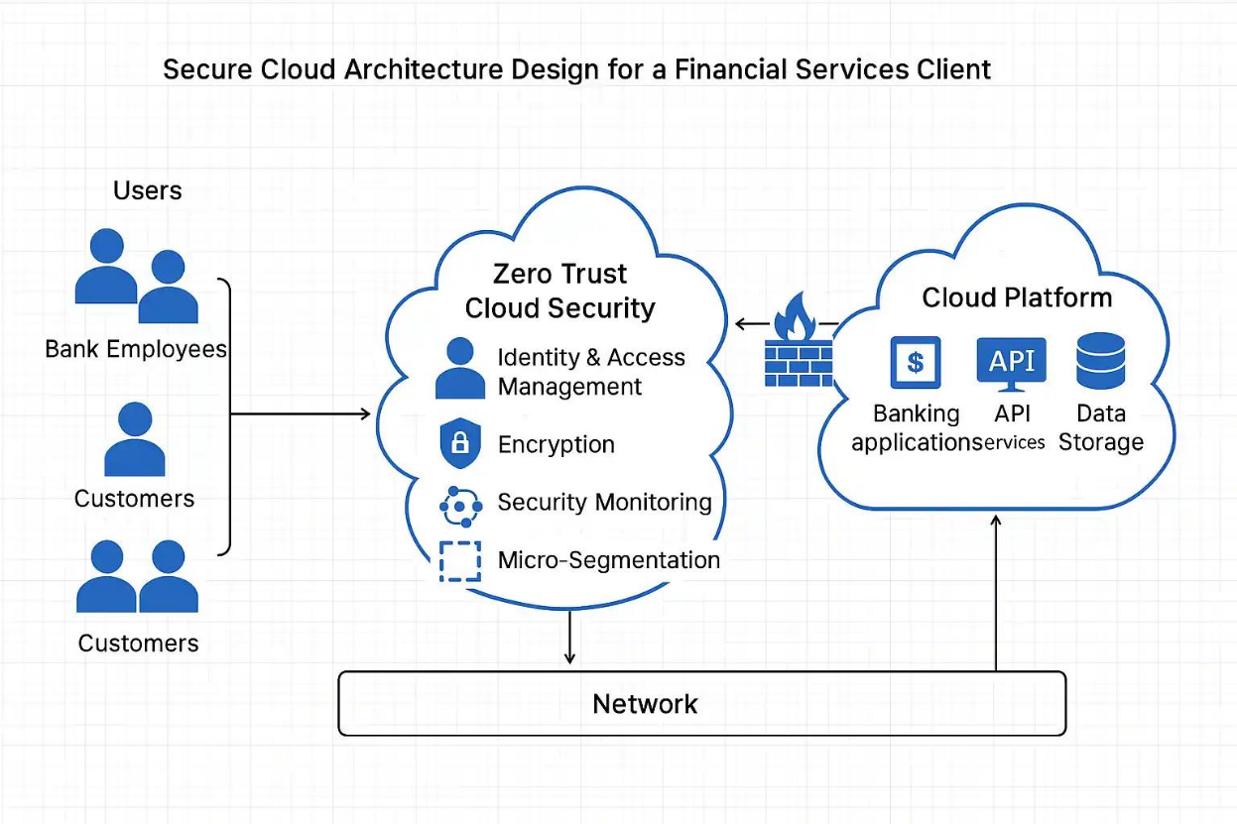

Question 5: Containers, Virtual Machines, and Orchestration
Question: A development team wants to adopt containerization for application deployment. Explain how containers differ from virtual machines in terms of performance and resource usage. How does orchestration (like Kubernetes) simplify deployment and scaling? Discuss portability benefits across different cloud environments. Provide an example of a microservices-based application.

Answer
Virtual machines (VMs) virtualize hardware and typically run a separate guest operating system on a hypervisor. Each VM has its own operating system environment, which provides strong isolation but uses additional memory, storage, and startup time. Containers package an application and its dependencies while sharing the host operating system kernel. Because containers do not each need a full guest operating system, they are generally lighter, start faster, and allow higher workload density on the same host. The degree of isolation and security depends on configuration and the runtime; containers and VMs are not identical security boundaries.
Container images make deployments more consistent by packaging application code, libraries, and runtime dependencies together. This helps reduce differences between development, testing, and production environments. Containers can run on developer machines, on-premises servers, and supported cloud platforms, provided the required container runtime, CPU architecture, networking, storage, and platform services are available. Portability is improved, but it is not absolute: cloud-specific databases, identity systems, networking, and managed services can still create dependencies.
Kubernetes is a container orchestration platform that manages containerized workloads across a cluster. It can schedule containers onto available nodes, restart failed containers, maintain a desired number of replicas, perform rolling updates, support service discovery, and scale workloads based on configured metrics. It also provides configuration and secret management mechanisms, though secrets still need careful protection. Orchestration reduces manual operational work, but teams must still design secure configurations, monitoring, backups, and capacity policies.
Example: An online food-delivery application may use separate microservices for customer accounts, restaurant listings, order processing, payment handling, notifications, and delivery tracking. Each service can be packaged in a container and deployed independently. Kubernetes can maintain multiple replicas of the order service during a busy period, restart failed containers, and roll out an updated restaurant-listing service gradually. This supports independent scaling and releases, while service-to-service authentication, network policies, observability, and reliable data management remain important.

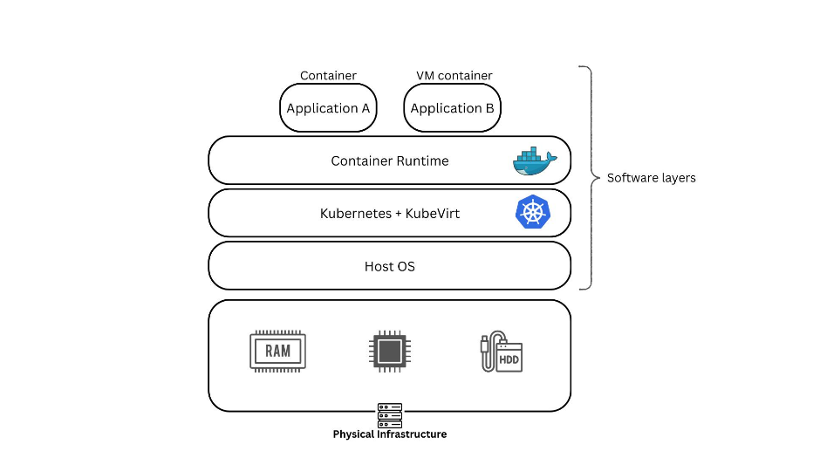

Conclusion
Cloud services can improve scalability, resilience, global performance, backup protection, security operations, and deployment consistency when they are designed and configured appropriately. Auto-scaling and load balancing help manage changing demand; redundant cloud storage and tested recovery plans protect backups; CDNs and edge locations reduce delivery latency; compliance depends on controls, evidence, and customer responsibilities; and containers with orchestration support repeatable deployment and scaling. Across all five scenarios, effective monitoring, least-privilege access, encryption, cost awareness, and regular testing are essential.

